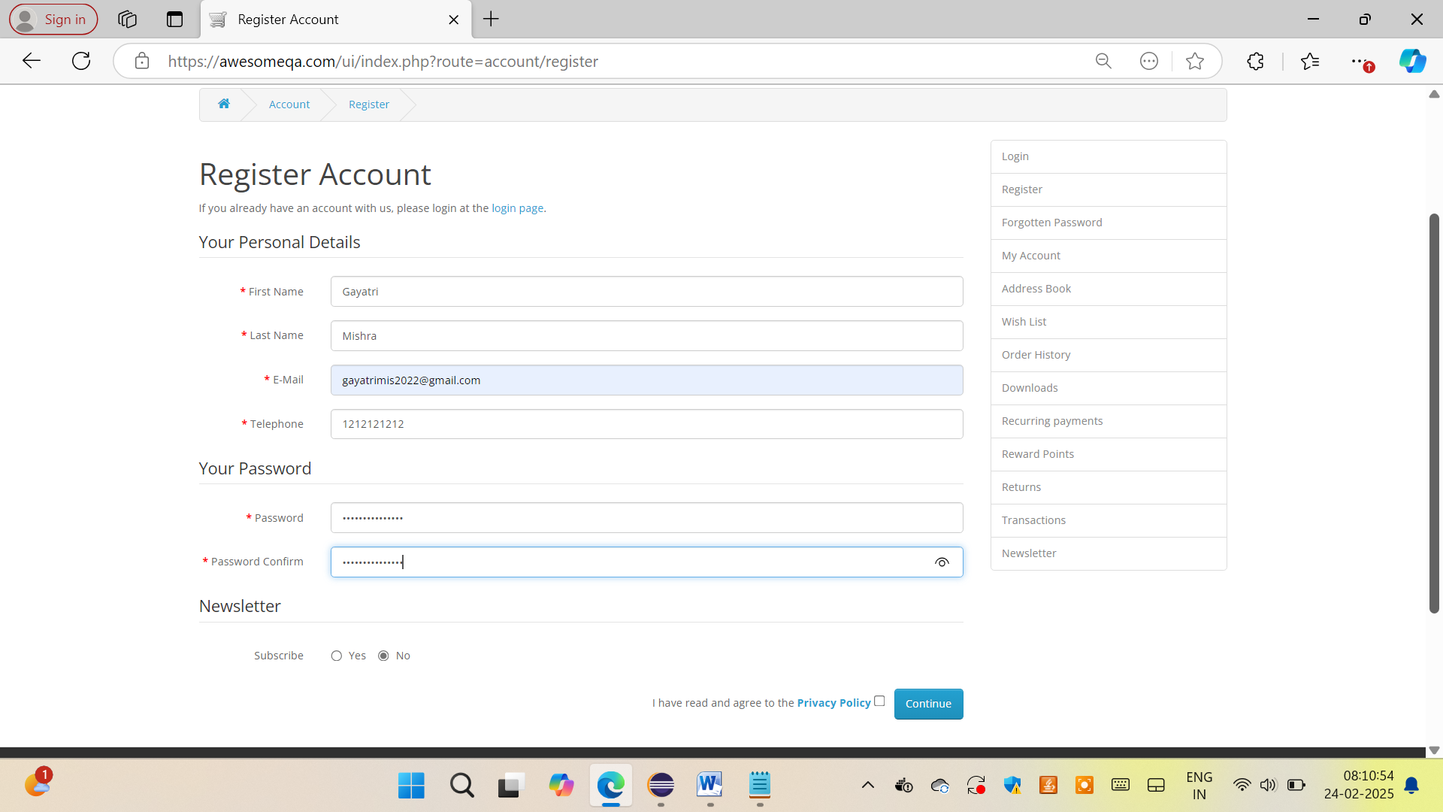

awesomeqa@123

Resizing Window :

wd.manage().window().setSize(**new** org.openqa.selenium.Dimension(500, 500));

Log info capture in TestNG :

Reporter.log(“String data”);

#id

TagName[p1=’val’]

//Actions

Actions act = **new** Actions(wd);

act.dragAndDrop(srcel, dest1).perform();

Chained Xpath:

Xpath of the UserName or email inside Login form of awesomeqa

//*[@action="https://awesomeqa.com/ui/index.php?route=account/login"]//*[@id='input-email']

<html>

<head> xpath demo </head>

<body>

<bookstore>

<book>

<title>Learning XPath</title>

<author>John Doe</author>

</book>

<book>

<title>XPath Basics</title>

<author>Jane Smith</author>

</book>

</bookstore>

</body>

<heml>

| **Axis** | **Description** | **Example** |
| --- | --- | --- |
| Child | Selects the children of the current node. | //book/child::* |
| Parent | Selects the parent of the current node. | //title/parent::* |
| ancestor | Selects all ancestors of the current node. | //title/ancestor::* |
| descendant | Selects all descendants of the current node. | //bookstore/descendant::* |
| following-sibling | Selects all siblings after the current node. | //title/following-sibling::* |
| preceding-sibling | Selects all siblings before the current node. | //title/preceding-sibling::* |
| following | Selects all nodes after the current node. | //book/following::* |
| preceding | Selects all nodes before the current node. | //book/preceding::* |
| self | Selects the current node. | //book/self::book |
| descendant-or-self | Selects the current node and all its descendants. | //book/descendant-or-self::* |
| ancestor-or-self | Selects the current node and all its ancestors. | //title/ancestor-or-self::* |
| attribute | Selects attributes of the current node. | //book/attribute::id |
| namespace | Selects the namespaces of the current node. | //book/namespace::* |
| root | Selects the root of the document. | /root::* |

Implicit Wait in Selenium works by setting a default wait time for the WebDriver to look for elements before throwing a NoSuchElementException. It is useful for scenarios where elements may take some time to load, but not necessarily because the page is entirely loaded. It will apply to all element searches in the current session.

driver.manage().timeouts().implicitlyWait(10, TimeUnit.SECONDS);

WebDriverWait :

WebDriverWait wait = **new** WebDriverWait(obj,Duration.*ofSeconds*(10));

wait.until(ExpectedConditions.*visibilityOfElementLocated*(By.*xpath*("(//button[@type=\"button\"])[1]")));

String opts = list.get(i).getText();